## **3.4 Architectural Model**

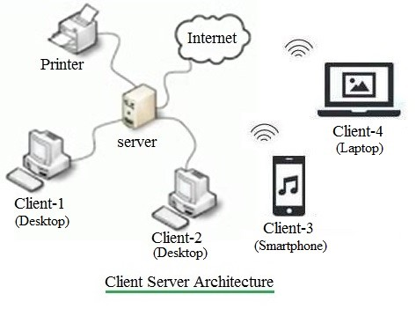s

The model used to represent the structure of the overall network used by the system is known as architectural model. For my project I am using the client server architecture. This architecture allows one or more clients systems to a centrally located server. The server holds the responsibility of controlling the services given to its clients.

The justifications for using this model in my project.

* Customers as well as the airlines system will have distinct and specific tasks.
* All data are in a centralized location, so recovering and backing up data is easy.
* Changes can be made easily in a centrally located data.